Name : Ghaskata Abhishek Maheshbhai
Roll No. : 25
Div : A
Project Title : Book Sharing Management System

1. Project Scope

1.1 Scope
Book Sharing Management System is mainly focus on Books where every student can share or donate their books to other student. Every student may not have enough money to buy a new books but may be they can afford some second hand books in which they can get knowledge out of it. so as a software developer we should do something for them. That’s why I want to make this system so it is useful to every student around the globe.

1.2 Objectives
The project aims to share or donate the books around the students. Student can share or donate their books using this mobile, web and PWA application(Now I am totally working on mobile application) via internet. Student can easily search books which they are looking for.

The objective of this project is to share or donate the books throughout the students and keep the records of it.

1.3 Feasibility Study

Feasibility study involves research relating to different aspects that into developing software. Feasibility study of the problem definition or requirement was done to determine if the requirement can be solved effectively given the budgetary, operational & technical and scheduled constraints in place. The aim of feasibility study is to identify the best solution under the circumstance by identifying the effects of this solution on the organization.

2. System Environment

2.1 Hardware Requirements

Client Side
Processor
Recommended: Dual Core or more..
Operating System
Website: Any operating system which supports browsers.
Application: Supports android and iOS operating system only.
RAM
Recommended: Minimum 1GB

Server Side
Processor
More than 2.0 GHZ
Operating System
Windows server or anything which can manage the server resource.
RAM
Minimum 4GB

2.2 Software Requirements

Client Side
Browser
Website: Any operating system which supports browsers.
Operating System
Application: Supports android and ios operating system only.

Development Description

Development Description
Software Requirement
Visual Studio Code, Sublime
PostgreSQL Database
Flutter (Front End)
Django, Python (Back End)
Operating System
GUI based
Server Configuration
Website: 127.0.0.1:8000/192.168.43.182:8000 server
Application: Flutter metro bundler server
Client Side
Website: Operating system which supports browsers.
3. System Analysis and Modeling

3.1. SRS

1. Overall Description

1.1 Use cases

The Admin and student is the main user of this application. The system is also designed to be user-friendly.

Admin
Students

Admin : Admin is admin of this application who is manage the students, books and feedbacks. Admin can do interaction with this system using Admin Panel which is Django based Admin Panel. HODs have authority to manage Students, Books by editing and deleting.

Students : students can post a books which they want to share or donate. They can also give feedback about the application. Interested students can call the students who is posted particular book. Students can search interested books throughout the application.

1.2 Operating Environment

This proposed software will be used in Android, iOS in version of above Android is 6.0 and for iOS devices is usually above iOS 12. Django and PostegresSQL will be used for the database to hold the details of student and books.

Operating system: Windows 10 pro
Processor: I7 – 4600U
Processor speed: 2.69 GHz
RAM: 8GB
MSata 2: 240GB

1.3. Design and Implementation Constraints

This system shall be mobile, web and PWA based application(Now I am totally working on mobile application). I am developing it using Windows 10 pro. This system is used Django as a backend and use PostgresSQL database. This document follows IEEE standard for software requirement specification.

1.4. General Constraints

The System must be delivered by deadline.
The system must be user-friendly.

1.5. Assumptions and Dependencies

It is assumed that this application working perfectly in iOS devices and as a web app or PWA.

Details SRS

Managing login:
CRUD operations are performed by admin
Inputs/outputs: necessary detail for login like enrollment number and password
Validation: enrollment and password exist in the table or not

Managing Student:
CRUD operation along with filtering, sorting and searching
Inputs/outputs: necessary detail for Student
Validation: required field validation on required field, valid format check, Enrollment number and student name already exist

Managing Books:
CRUD operations are performed by admin and student
Inputs/outputs: necessary detail for books like ISBN number, title, price etc…
Validation: books should be available

Managing registration:
Insert and update operation performed by student. CRUD operation performed by admin
Inputs/outputs: necessary detail for registration like enrollment number, student name, college name etc….
Validation: required field validation on required field

Managing Purchased Books:
CRUD operation performed by admin
Insert, show, search operation by student
Inputs/outputs: required phone number and student name. Student should be exist in table.
Validation: required field validation on required field. Phone number/Name should be exist in student table

Timeline Chart

Week | 1 | 2 | 3 | 4 | 5 | 6 | 7 | 8 | 9 | 10 | 11 | 12 | 13 | 14 | 15
Task Name
1)Requirement Analysis

Collected requirement from our guide
Analyse gathered information
Determine different modules
2)Planning & Risk
Analysis

Analyse data for possible risk
Identify technical risk
Determine different modules
3) Designing

Design basic interface of the site
Design database tables
Design web form for modules

4)Coding and integrating
modules

Implement logic for different modules
Implement database connectivity
Implement report
integrate different modules
5)Testing

Validate input control and check accuracy of Reports

Entity-Relationship Diagram
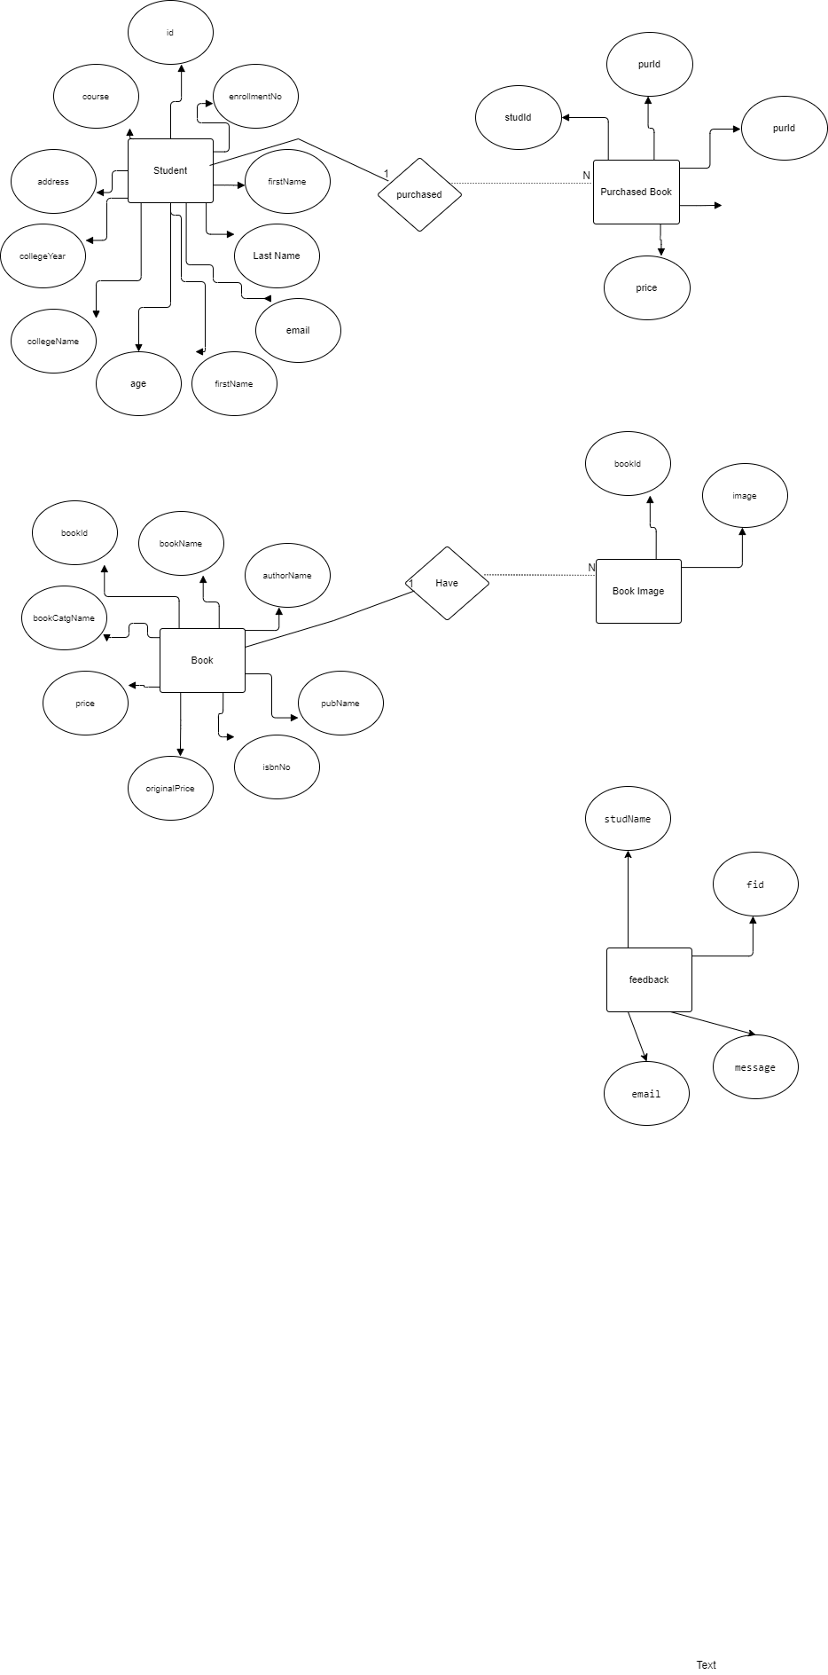

Data Flow Diagram

Level 0 DFD

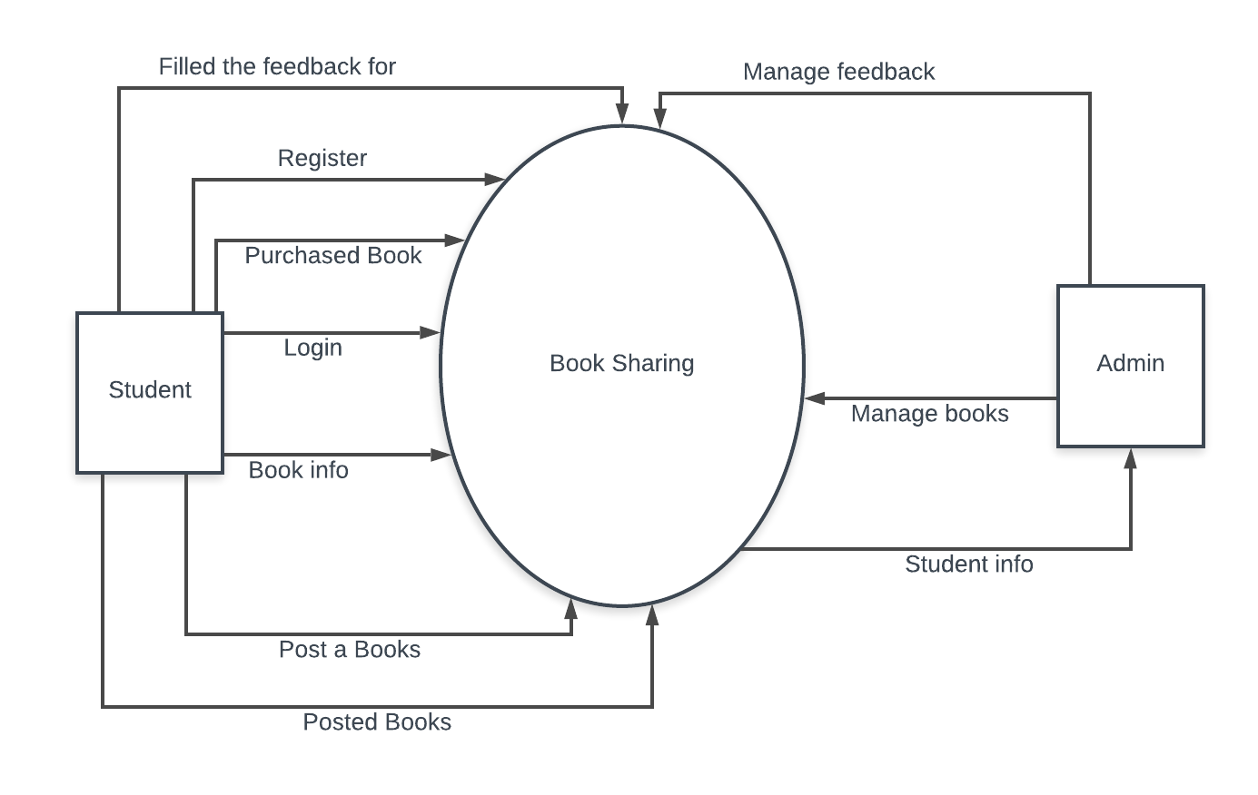

Admin : Level 1 DFD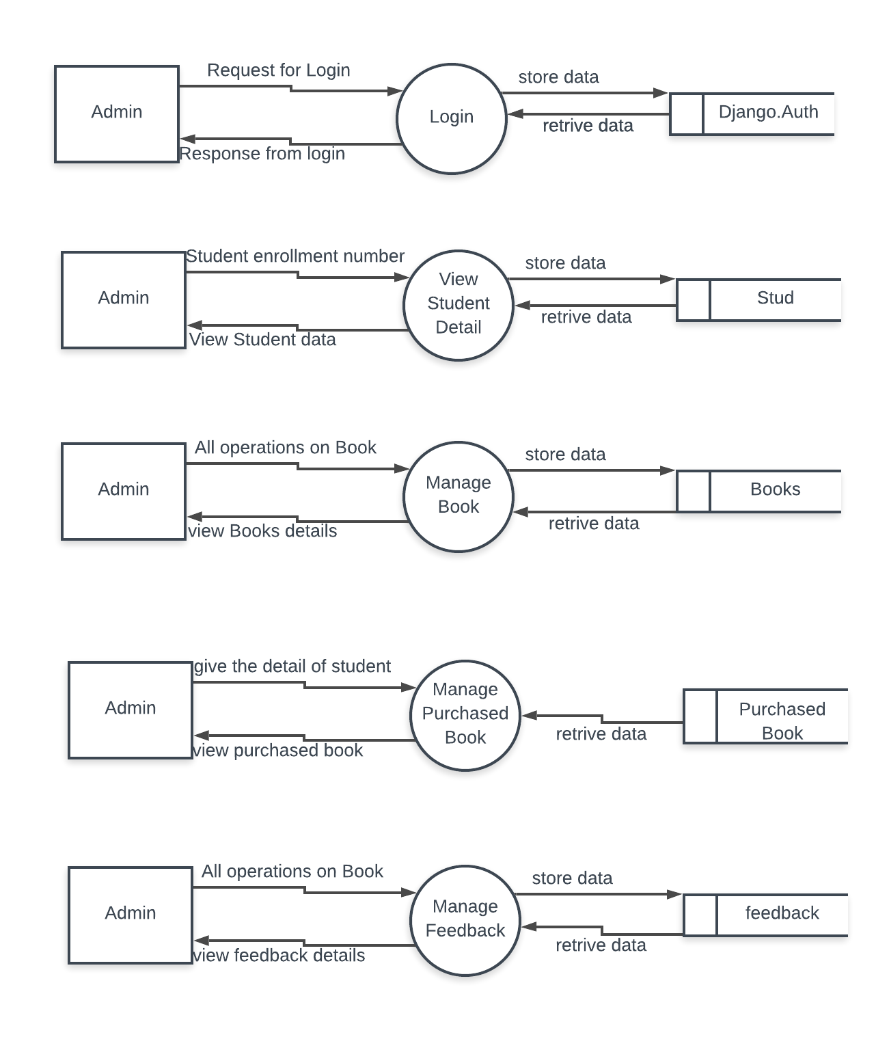

Student : Level 1 DFD
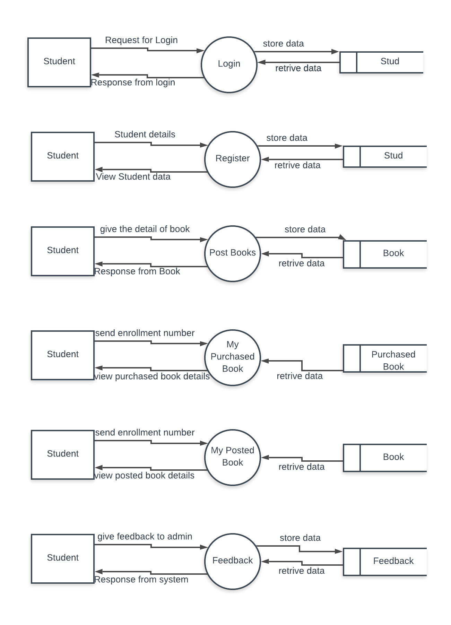
Use Case Diagram for Admin

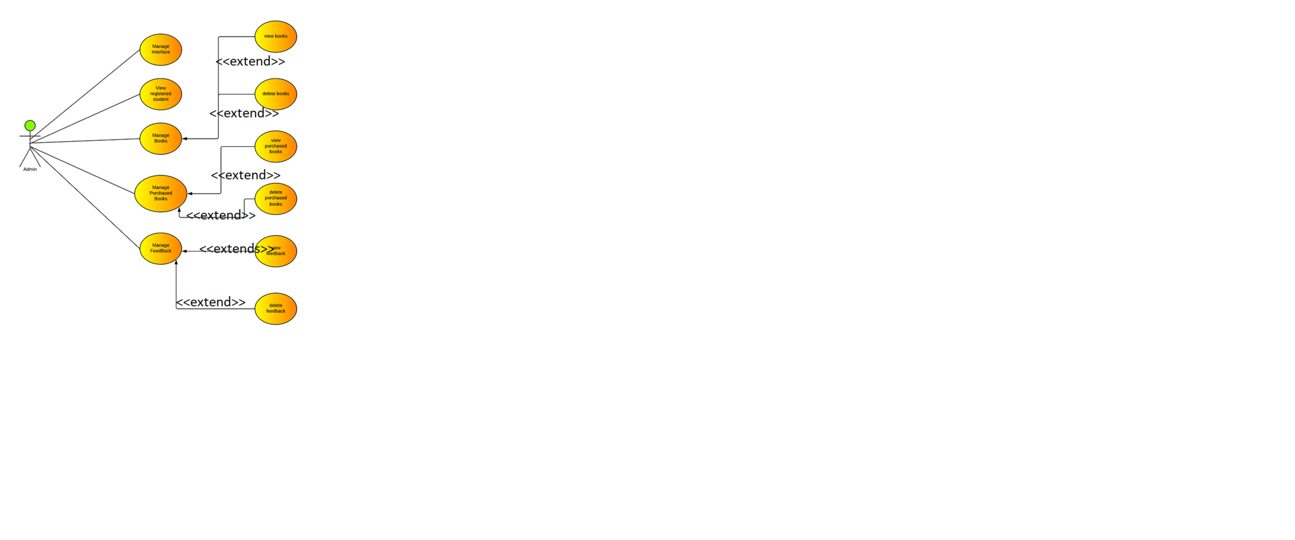

Use Case Diagram for Student
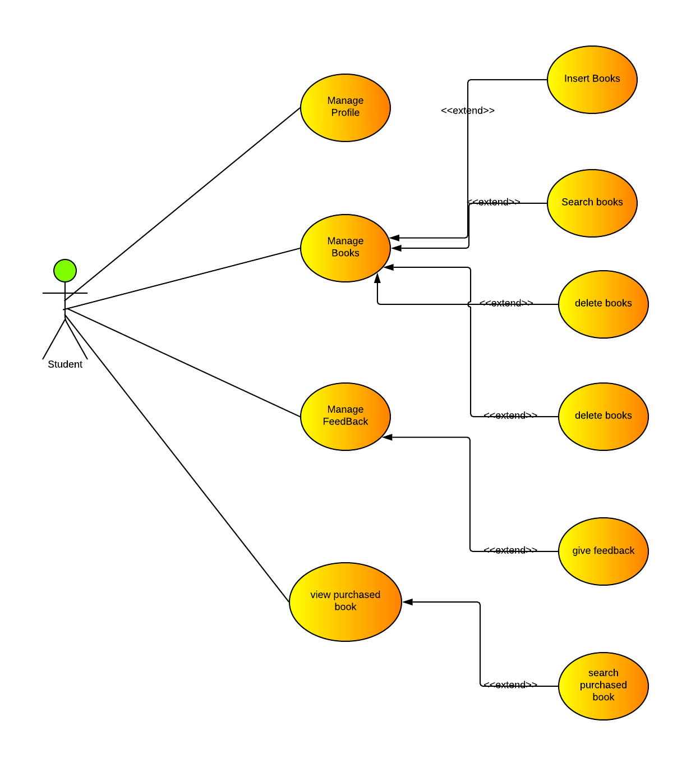

Class Diagram

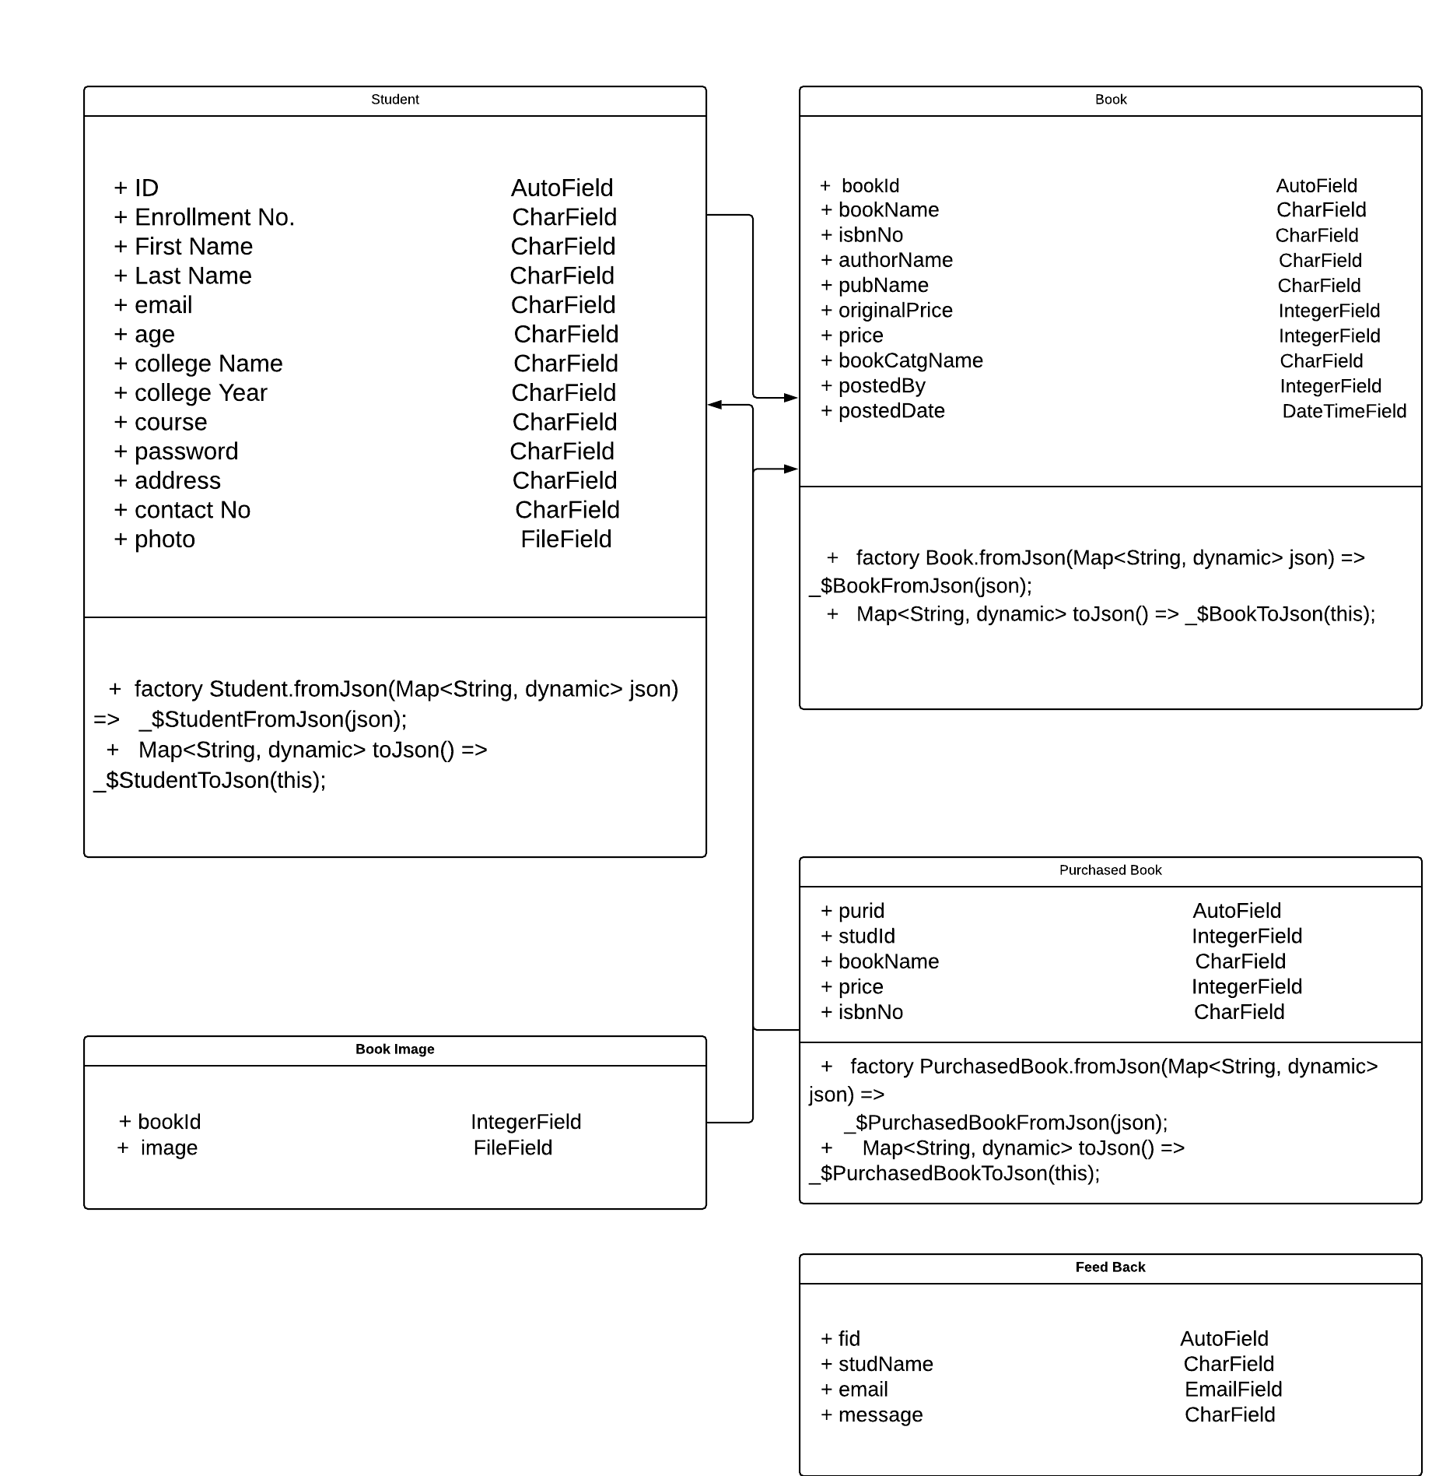

System Design
(Designing)

Database Design
1. Student
- The Student table is used to store the information about Student
Column Name | Data Type | Constraints | Desc.
id | int | PK AI NN | -
enrollmentNo | String | NN | -
firstName | String | NN | -
lastName | String | NN | -
email | int | NN | -
age | String | NN | -
collegeName | int | NN | -
collegeYear | String | NN | -
course | String | NN | -
password | String | NN | -
photo | String | NN | -
contactNo | String | NN | -
address | String | NN | -

2. Book
- The Book table is used to store the information of books
Column Name | Data Type | Constraints | Desc.
bookId | int(11) | PK AI NN | -
bookName | String | NN | -
authorName | String | NN | -
pubName | String | NN | -
isbnNo | String | NN | -
originalPrice | int | NN | -
price | int | NN | -
bookCatgName | String | NN | -
postedBy | int | FK(Student)NN | -
bookImage | int(11) | NN | -
postedDate | String | NN | -

3. Purchased Book
- The Purchased Book table is used to store the information of purchased books
Column Name | Data Type | Constraints | Desc.
purId | int | PK AI NN | -
studId | int | FK(Student)NN | -
bookName | String | NN | -
price | int | NN | -
isbnNo | String | NN | -

4. Book Image
- The Book Image table is used to store the information of book image
Column Name | Data Type | Constraints | Desc.
bookId | int | FK(Book) NN | -
image | String | NN | -

5. Feed Back
- The Feed Back table is used to store the information of all the feed back given by the Student
Column Name | Data Type | Constraints | Desc.
fid | int | PK AI NN | -
studName | string | NN | -
email | string | NN | -
message | string | NN | -

